Experiment No: Date:

CLIPPERS AND CLAMPERS

**Aim:**

To study the following diode application circuits.

* Positive and Negative Clippers
* Positive and Negative Clampers

**Components Required:**

AC voltage source, Voltage Measurement, Block, Diodes, Series RLC branch, Scope, Powergui.

**Theory:**

Clipping circuits (also known as limiters, amplitude selectors, or slicers), are used to remove the part of a signal that is above or below some defined reference level. When the diode is forward biased, it acts as a closed switch, and when it is reverse biased, it acts as an open switch. Different levels of clipping can be obtained by varying the amount of voltage of the battery and also interchanging the positions of the diode and resistor. Depending on the features of the diode, the positive or negative region of the input signal is “clipped” off and accordingly the diode clippers may be positive or negative clippers.

There are two general categories of clippers: series and parallel (or shunt).

The series configuration is defined as one where a diode is in series with the load, while the shunt clipper has the diode in a branch parallel to the load.

**Positive Diode Clipper**

In a positive clipper, the positive half cycles of the input voltage will be removed. The circuit arrangements for a positive clipper

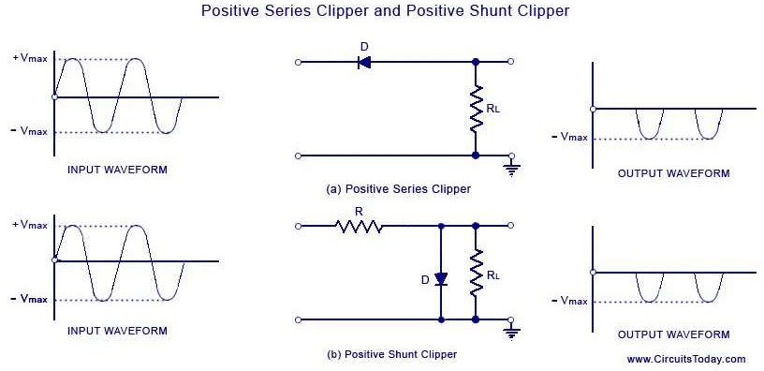

As shown in the figure(a), the diode is kept in series with the load. During the positive half cycle of the input waveform, the diode ‘D’ is reverse biased, which maintains the output voltage at 0 Volts. This causes the positive half cycle to be clipped off. During the negative half cycle of the input, the diode is forward biased and so the negative half cycle appears across the output.

In Figure (b), the diode is kept in parallel with the load. During the positive half cycle, the diode ‘D’ is forward biased and the diode acts as a closed switch. This

causes the diode to conduct heavily. This causes the voltage drop across the diode or across the load resistance RL to be zero.Thus output voltage during the positive half cycles is zero. During the negative half cycles of the input signal voltage, the diode D is reverse biased and behaves as an open switch. So, the entire input voltage appears across the diode or across the load resistance RL if R is much smaller than RL.

**Negative Diode Clipper**

The negative clipping circuit is almost the same as the positive clipping circuit, with only one difference. If the diode in figures (a) and (b) is reconnected with reversed polarity, the circuits will become for a negative series clipper and negative shunt clipper respectively. The negative series and negative shunt clippers are shown in figures (a) and (b) as given below.

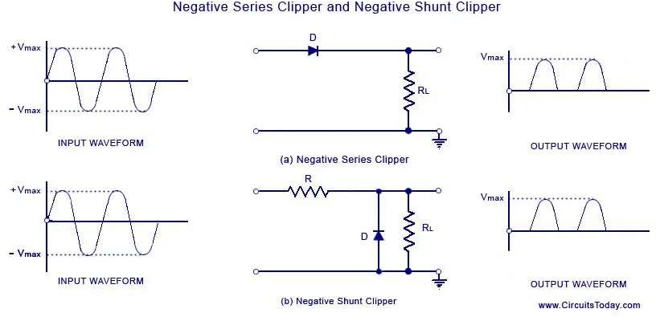

**Clampers**

Clamping circuits, also known as dc restorers or clamped capacitors, shift an input signal by an amount defined by an independent voltage source.

A Clamper Circuit is a circuit that adds a DC level to an AC signal. Actually, the positive and negative peaks of the signals can be placed at desired levels using the clamping circuits. As the DC level gets shifted, a clamper circuit is called as a **Level Shifter**.

Clamper circuits consist of energy storage elements like capacitors. A simple clamper circuit comprises of a capacitor, a diode, a resistor and a dc battery if required.

In a **positive clamper** circuit, the waveform will shift above the reference axis.

Initially when the input is given, the capacitor is not yet charged and the diode is reverse biased. The output is not considered at this point of time. During the negative half cycle, at the peak value, the capacitor gets charged with negative on one plate and positive on the other. The capacitor is now charged to its peak value Vm. The diode is forward biased and conducts heavily. During the next positive half cycle, the capacitor is charged to positive Vm while the diode gets reverse biased and gets open circuited. The output of the circuit at this moment will be

V0=Vi+Vm

Hence the signal is positively clamped as shown in the above figure. The output signal changes according to the changes in the input, but shifts the level according to the charge on the capacitor, as it adds the input voltage.

In **Negative clamper, th**e waveform will shift below the reference axis. During the positive half cycle, the capacitor gets charged to its peak value vm. The diode is forward biased and conducts. During the negative half cycle, the diode gets reverse biased and gets open circuited. The output of the circuit at this moment will be

V0=Vi+Vm

Hence the signal is negatively clamped as shown in the above figure. The output signal changes according to the changes in the input, but shifts the level according to the charge on the capacitor, as it adds the input voltage.

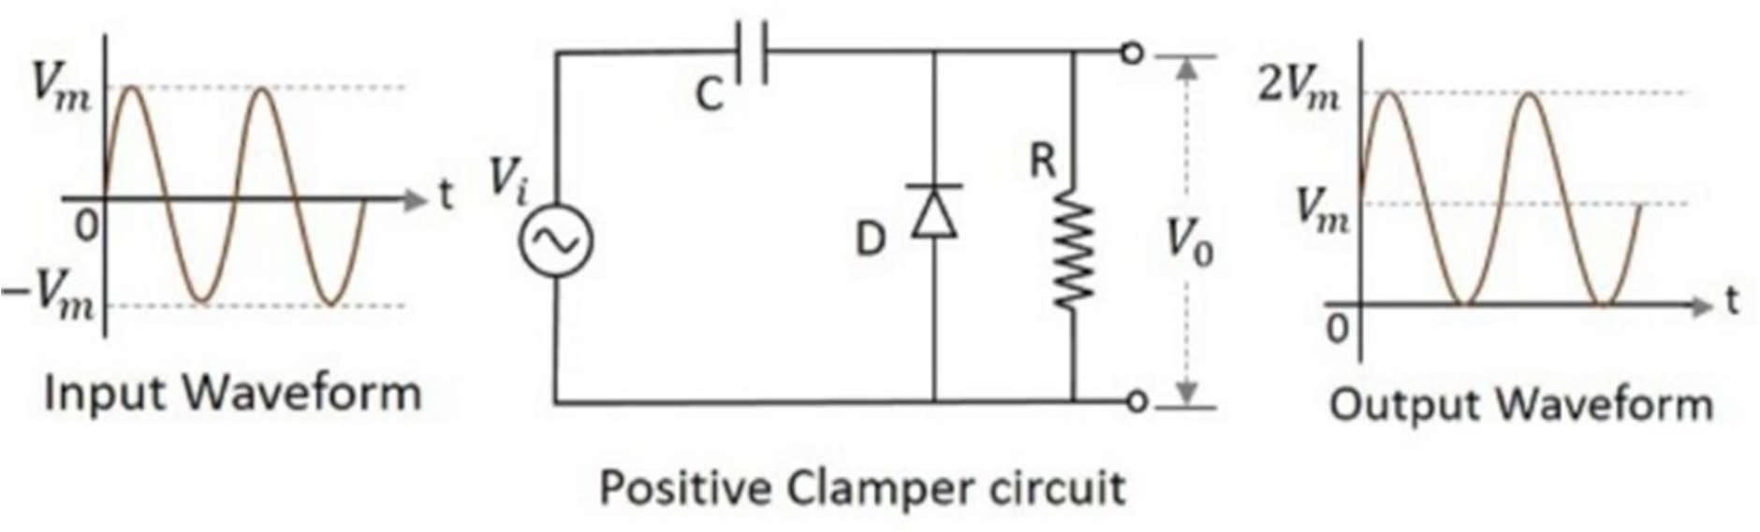

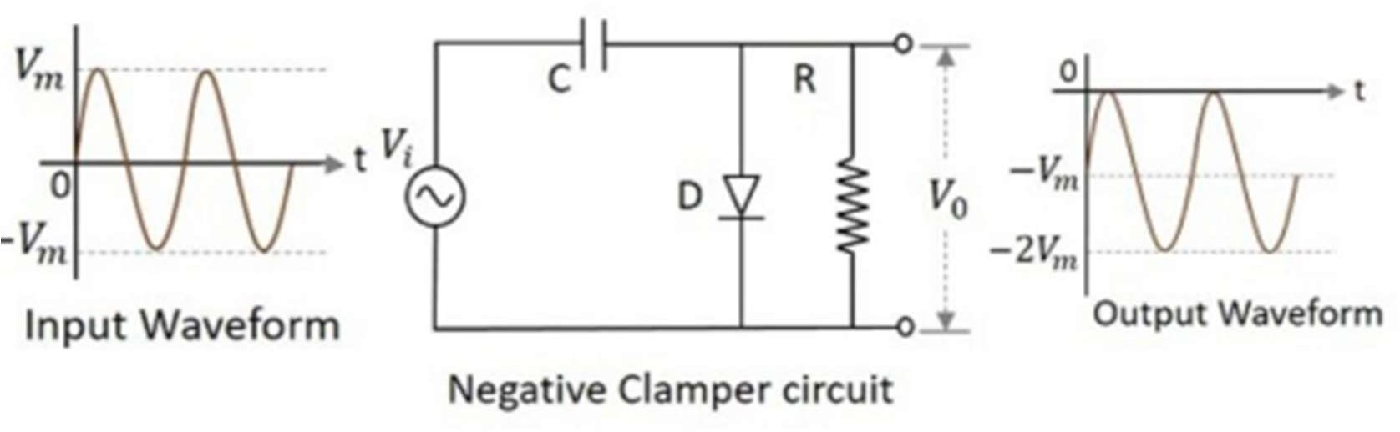

**Procedure:**

Draw the circuits and simulate them.

**Graphs:**

**Positive Series Clipper: Scope:**

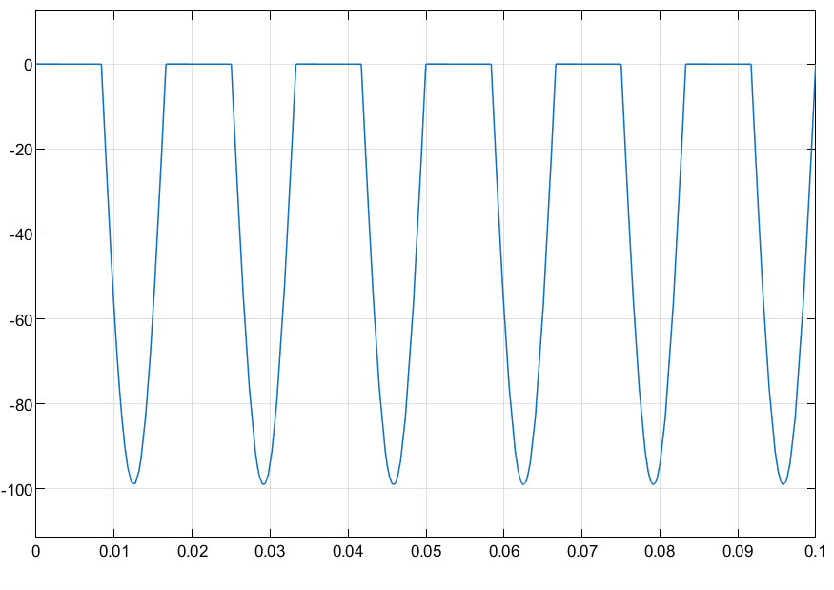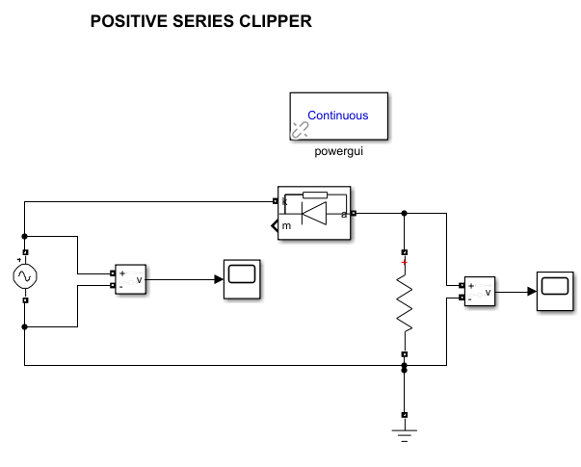

**Positive shunt Clipper: Scope:**

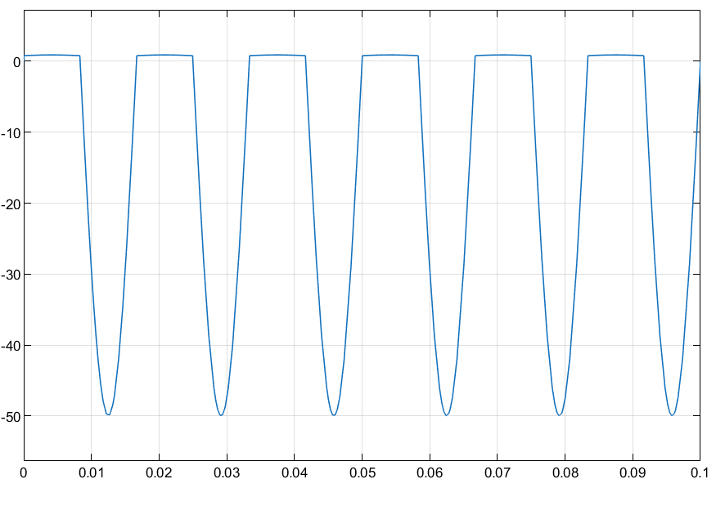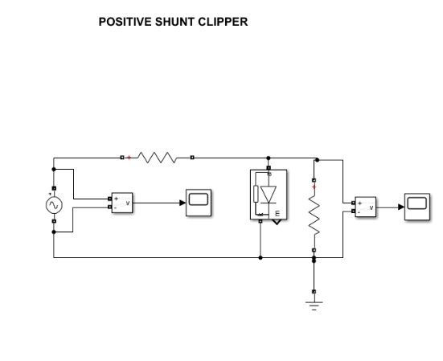

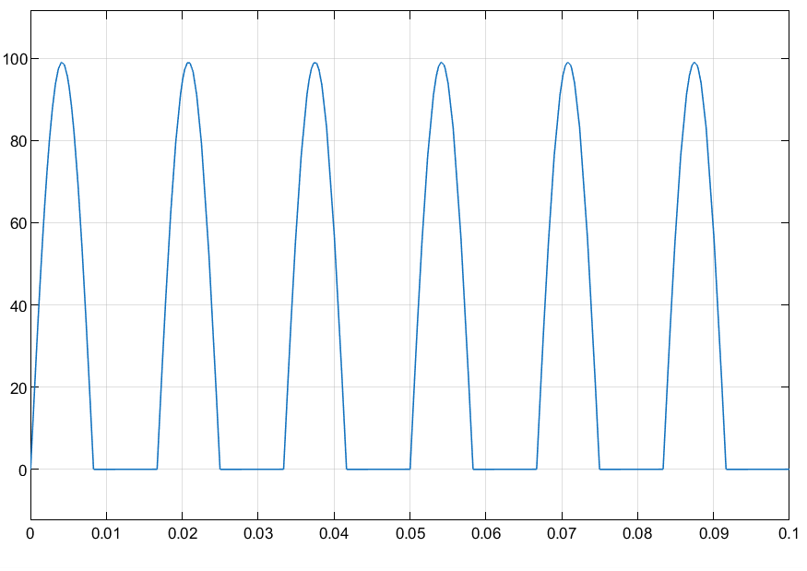**Negative Series Clipper: Scope:**

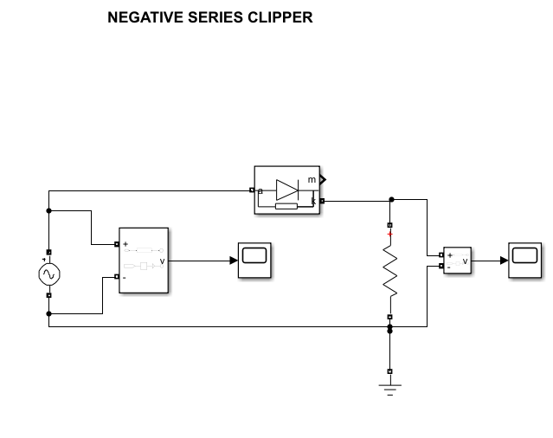

**Negative Shunt Clipper: Scope:**

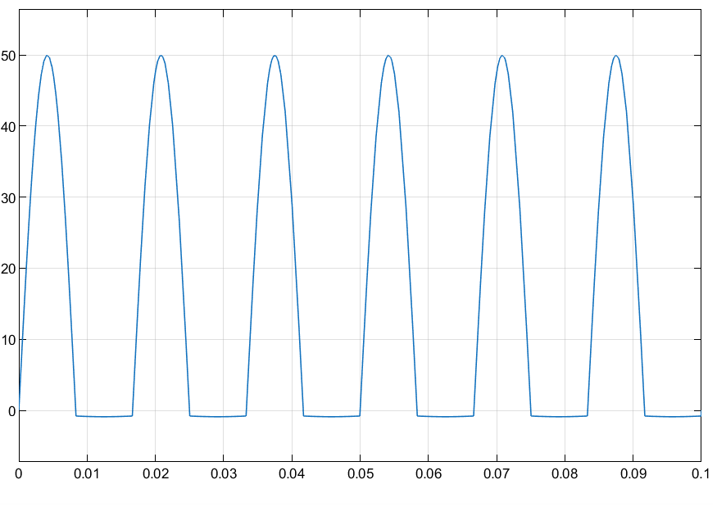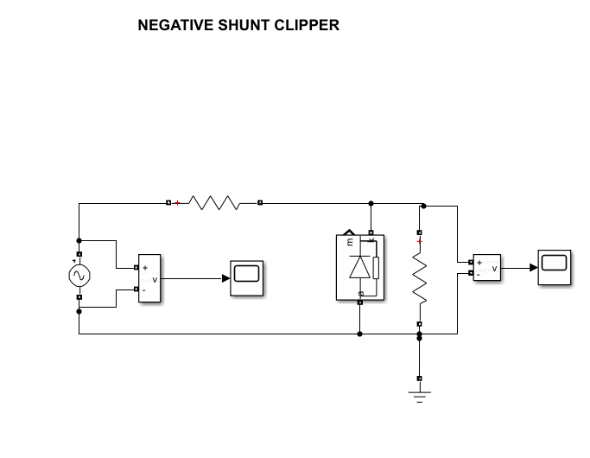

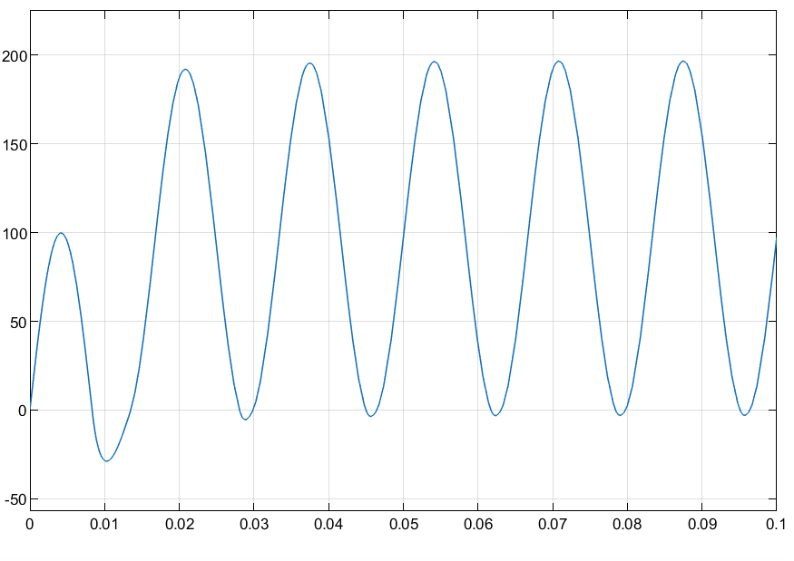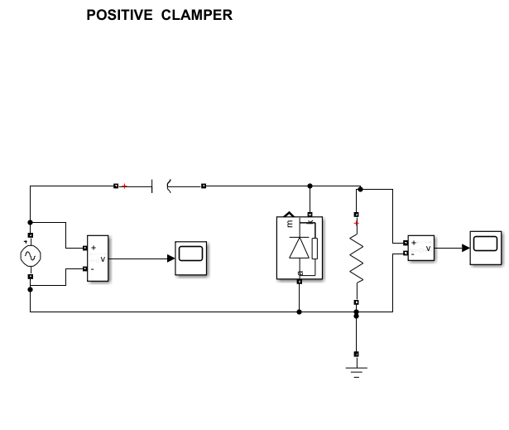 **Positive Clamper: Scope:**

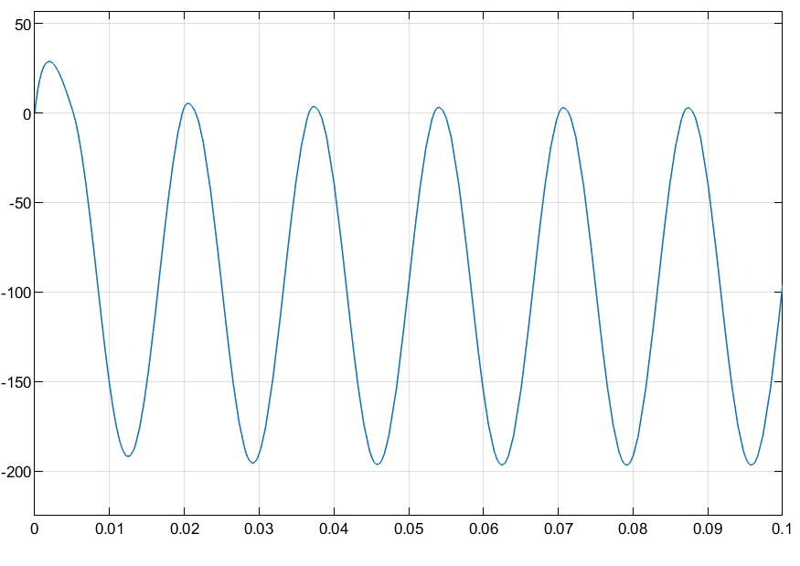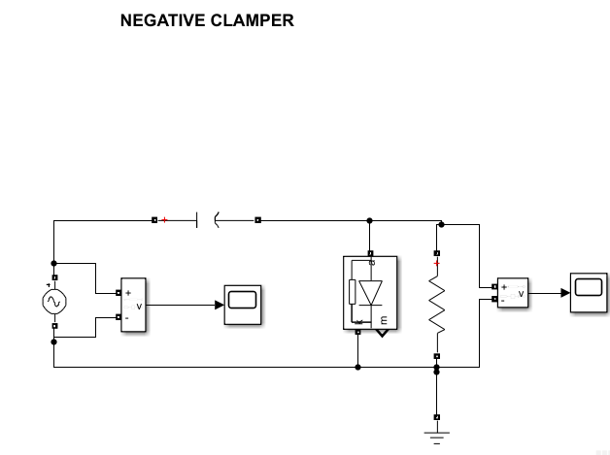**Negative Clamper: Scope:**

**Results & Inference**

Clipper and Clamper circuits have been proved.